**Naresh Kumar**

**22IT3025**

**Web Technology**

**Lab – 1**

**Example 1 .**

<!DOCTYPE html>

<html lang="en">

<head>

<meta charset="UTF-8">

<meta name="viewport" content="width=device-width, initial- scale=1.0"> <title>Naresh_Document</title>

</head>

<body>

</body>

</html>

**Output**

**Example 2 .**

<!DOCTYPE html>

<html lang="en">

<head>

<!-- HTML4: Explicit closing tags --> <meta charset="UTF-8"></meta>

<!-- HTML5: Omitted closing tags for void elements -->

<meta charset="UTF-8">

<meta name="viewport" content="width=device-width, initial- scale=1.0"> <title>Naresh_Document</title>

</head>

<body>

</body>

</html>

**Output**

**Example 3 .**

<!DOCTYPE html>

<html lang="en">

<head>

<meta charset="UTF-8">

<meta name="viewport" content="width=device-width, initial- scale=1.0"> <title>Naresh_Document</title>

</head>

<body>

<!-- HTML4: Quotation required -->

<input type="text" name="username" value="John Doe">

<!-- HTML5: Quotation optional for certain values --> <input type=text name=username value="John Doe">

</body>

</html>

**Output**

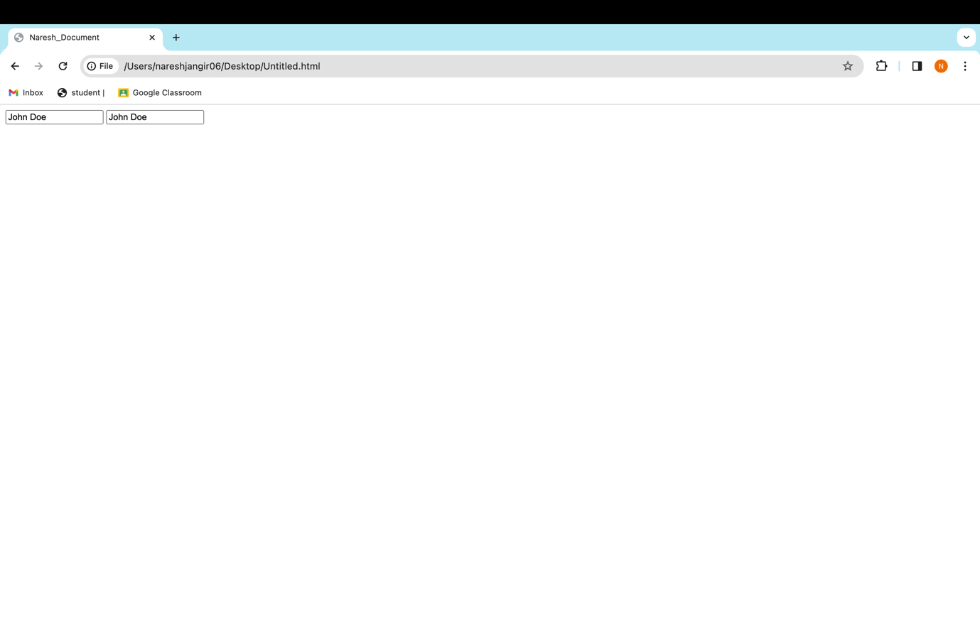

**Example 4 .**

<!DOCTYPE html>

<html lang="en">

<head>

<meta charset="UTF-8">

<meta name="viewport" content="width=device-width, initial- scale=1.0"> <title>Naresh_Document</title>

</head>

<body>

<!-- HTML4 and XHTML: Case-sensitive -->

<input Type="text" Name="username" Value="John Doe">

<!-- HTML5: Case-insensitive -->

<input type="text" name="username" value="John Doe">

</body>

</html>

**Output**

**Example 5 .**

<!DOCTYPE html> <html lang="en">

<head>

<meta charset="UTF-8">

<meta name="viewport" content="width=device-width, initial-scale=1.0"> <title>html_naresh_kumar</title>

</head>

<body>

<header>

<h1>Welcome to HTML Course</h1>

</header>

<nav>

<ul>

<li><a href="#home">Home</a></li>

<li><a href="#about">About</a></li>

<li><a href="#contact">Contact</a></li>

</ul>

</nav>

<section>

<h2>About Us</h2>

<p>Lorem ipsum dolor sit amet, consectetur adipiscing elit...</p>

</section>

<footer>

<p>&copy; 2023 My Website. All rights reserved.</p>

</footer>

</body>

</html>

**Output**

**Example 6 .**

<!DOCTYPE html> <html lang="en">

<head>

<meta charset="UTF-8">

<meta name="viewport" content="width=device-width, initial-scale=1.0"> <title>html_naresh_kumar</title>

</head>

<body>

<header>

<h1>Welcome to HTML Course</h1>

</header>

<nav>

<ul>

<li><a href="#home">Home</a></li>

<li><a href="#about">About</a></li>

<li><a href="#contact">Contact</a></li>

</ul>

</nav>

<section>

<h2>About Us</h2>

<p>Lorem ipsum dolor sit amet, consectetur adipiscing elit...</p>

</section>

<footer>

<p>&copy; 2023 My Website. All rights reserved.</p>

</footer>

<!-- Document Language -->

<meta http-equiv="Content-Language" content="en">

<!-- Character Set for Forms -->

<meta http-equiv="Accept-Charset" content="UTF-8">

<!-- Prevent Search Engine Indexing -->

<meta name="robots" content="index, follow">

<!-- Author Meta Tag -->

<meta name="author" content="John Doe">

</body>

</html>

**Output**

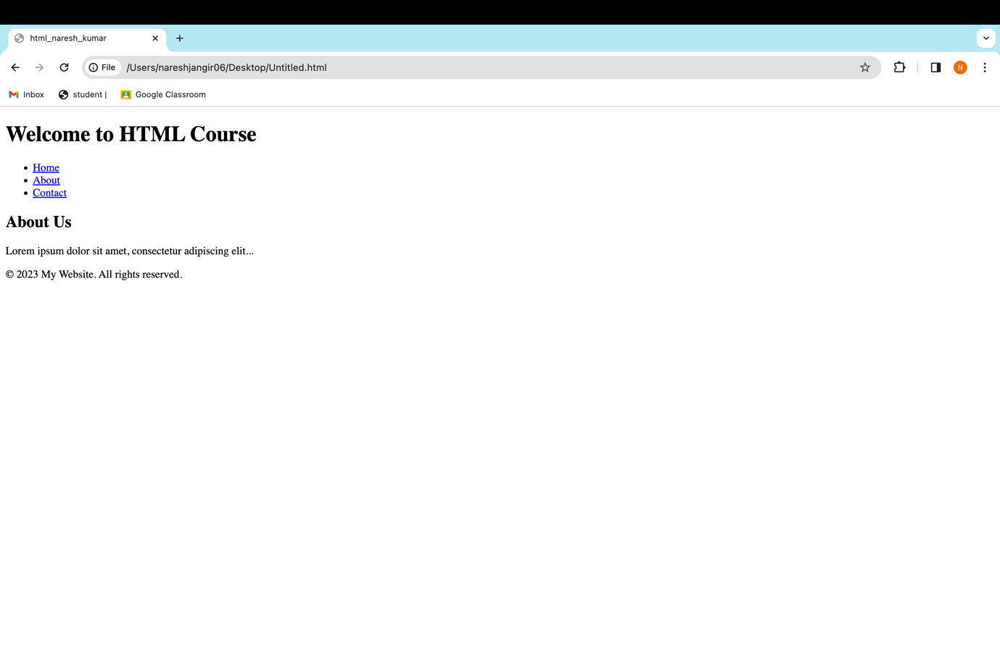

Example 7 .

<!DOCTYPE html> <html lang="en">

<head>

<meta charset="UTF-8">

<meta name="viewport" content="width=device-width, initial-scale=1.0"> <title>html_naresh_kumar</title>

</head>

<body>

<article>

<h2>Article Title</h2>

<p>Article content goes here.</p>

</article>

</body>

</html>

**Output**

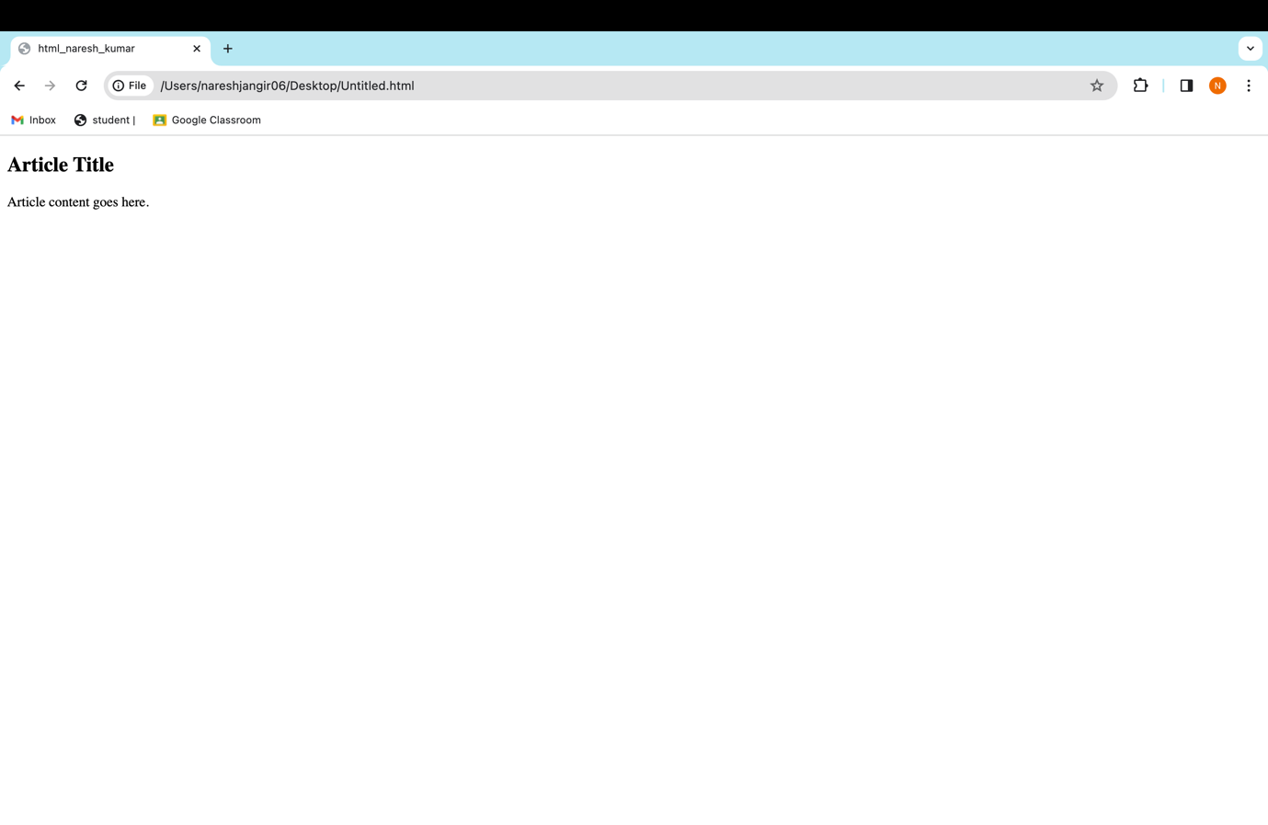

**Example 8.**

<!DOCTYPE html>

<html lang="en">

<head>

<meta charset="UTF-8">

<meta name="viewport" content="width=device-width, initial-scale=1.0"> <title>html_naresh_kumar</title>

</head>

<body>

<article>

<h2>Article Title</h2>

<p>Article content goes here.</p>

</article>

<main>

<h1>Main Content Heading</h1>

<p>Main content goes here.</p>

</main>

</body>

</html>

**Output**

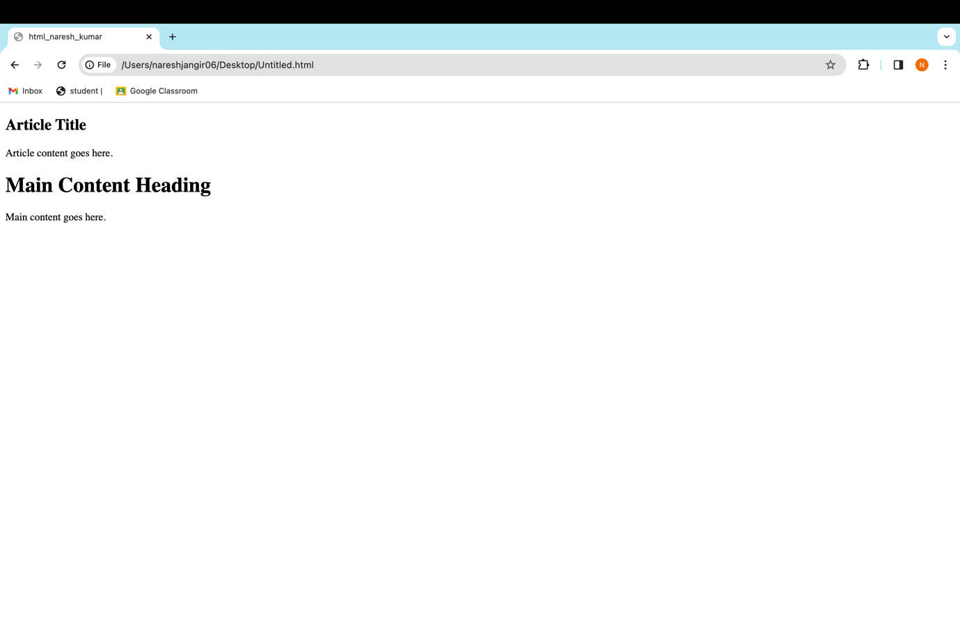

**Example 9 .**

<!DOCTYPE html> <html lang="en">

<head>

<meta charset="UTF-8">

<meta name="viewport" content="width=device-width, initial-scale=1.0"> <title>html_naresh_kumar</title>

</head>

<body>

<article>

<h2>Article Title</h2>

<p>Article content goes here.</p>

</article>

<main>

<h1>Main Content Heading</h1>

<p>Main content goes here.</p>

</main>

<aside>

<h2>Related Information</h2>

<p>Additional content goes here.</p>

</aside>

</body>

</html>

**Output**

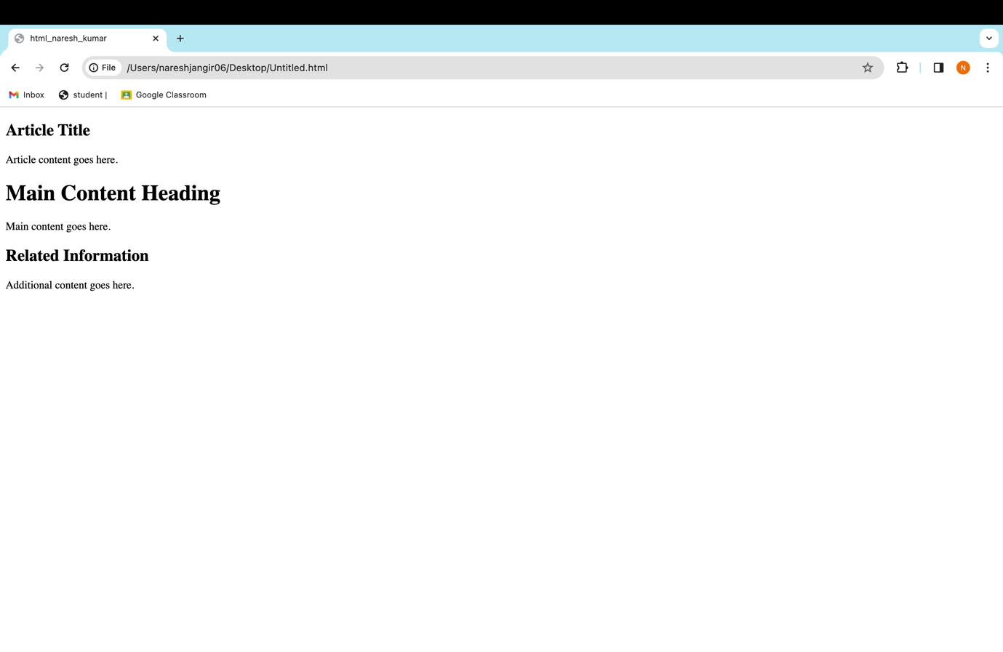

**Example 10.**

<!DOCTYPE html> <html lang="en">

<head>

<meta charset="UTF-8">

<meta name="viewport" content="width=device-width, initial-scale=1.0"> <title>html_naresh_kumar</title>

</head>

<body>

<article>

<h2>Article Title</h2>

<p>Article content goes here.</p>

</article>

<main>

<h1>Main Content Heading</h1>

<p>Main content goes here.</p>

</main>

<aside>

<h2>Related Information</h2>

<p>Additional content goes here.</p>

</aside>

<figure>

<img src="https://images.unsplash.com/photo-1595064085577-7c2ef98ec311?q=80&w=1000&auto=format&fit=crop&ixlib=rb-4.0.3&ixid=M3wxMjA3fDB8MHxzZWFyY2h8Mnx8ZWFybHklMjBtb3JuaW5nfGVufDB8fDB8fHww" width = 200px alt="Description">

<figcaption>Image Caption</figcaption>

</figure>

</body>

</html>

**Output**

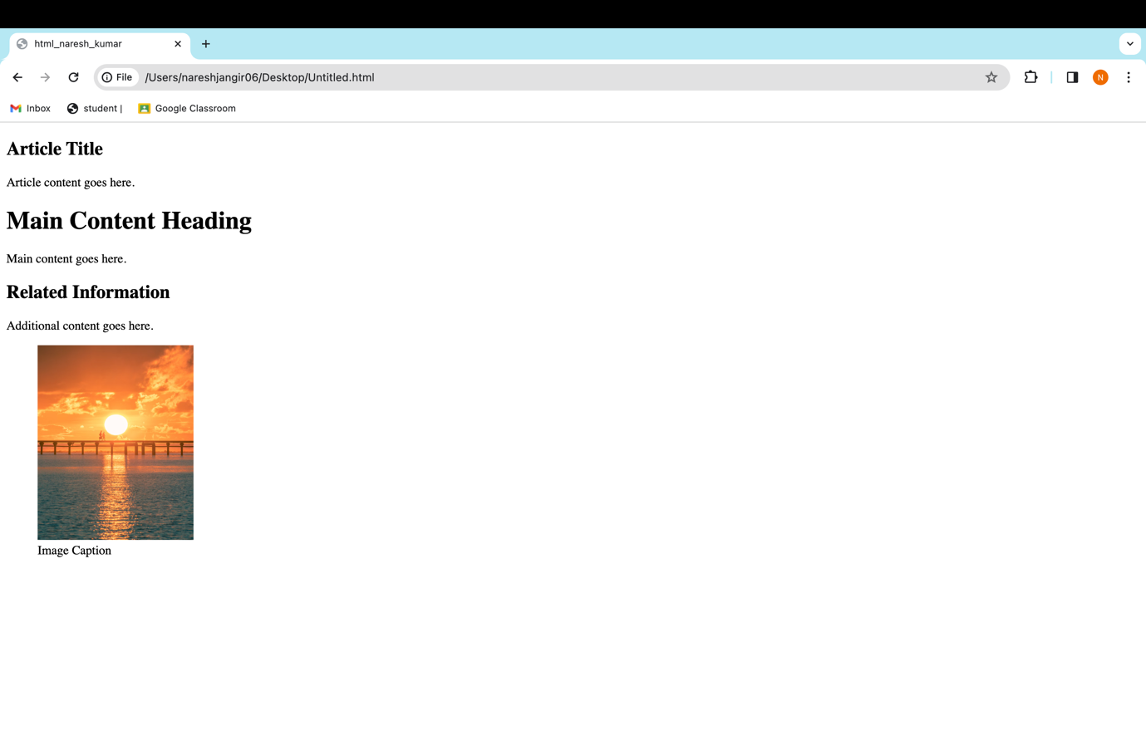

**Example 11.**

<!DOCTYPE html> <html lang="en">

<head>

<meta charset="UTF-8">

<meta name="viewport" content="width=device-width, initial-scale=1.0"> <title>html_naresh_kumar</title>

</head>

<body>

<article>

<h2>Article Title</h2>

<p>Article content goes here.</p>

</article>

<main>

<h1>Main Content Heading</h1>

<p>Main content goes here.</p>

</main>

<aside>

<h2>Related Information</h2>

<p>Additional content goes here.</p>

</aside>

<figure>

<img src="https://images.unsplash.com/photo-1595064085577-7c2ef98ec311?q=80&w=1000&auto=format&fit=crop&ixlib=rb-4.0.3&ixid=M3wxMjA3fDB8MHxzZWFyY2h8Mnx8ZWFybHklMjBtb3JuaW5nfGVufDB8fDB8fHww" width = 200px alt="Description">

<figcaption>Image Caption</figcaption>

</figure>

<div id="container">

<p>This is a paragraph inside a generic container.</p>

</div>

<span style="color: red;">This is inline text with red color.</span> <p>This is <b>bold</b> and <i>italic</i> text.</p>

</body>

</html>

**Output**

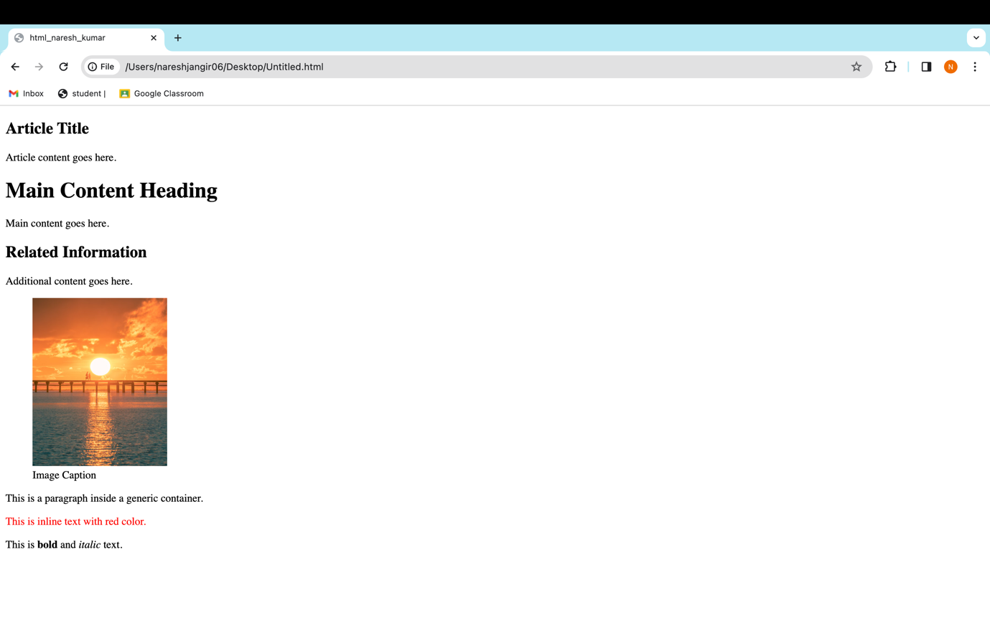

**Example 12.**

<!DOCTYPE html> <html lang="en">

<head>

<meta charset="UTF-8">

<meta name="viewport" content="width=device-width, initial-scale=1.0"> <title>html_naresh_kumar</title>

</head>

<body>

<article>

<h2>Article Title</h2>

<p>Article content goes here.</p>

</article>

<main>

<h1>Main Content Heading</h1>

<p>Main content goes here.</p>

</main>

<aside>

<h2>Related Information</h2>

<p>Additional content goes here.</p>

</aside>

<figure>

<img src="https://images.unsplash.com/photo-1595064085577-7c2ef98ec311?q=80&w=1000&auto=format&fit=crop&ixlib=rb-4.0.3&ixid=M3wxMjA3fDB8MHxzZWFyY2h8Mnx8ZWFybHklMjBtb3JuaW5nfGVufDB8fDB8fHww" width = 200px alt="Description">

<figcaption>Image Caption</figcaption>

</figure>

<div id="container">

<p>This is a paragraph inside a generic container.</p>

</div>

<span style="color: red;">This is inline text with red color.</span> <p>This is <b>bold</b> and <i>italic</i> text.</p>

<audio controls>

<source src="/Users/nareshjangir06/Downloads/Main-Rang-Sharbaton-Ka(PaglaSongs).mp3" type="audio/mp3"> Your browser does not support the audio tag.

</audio>

</body>

</html>

**Output**

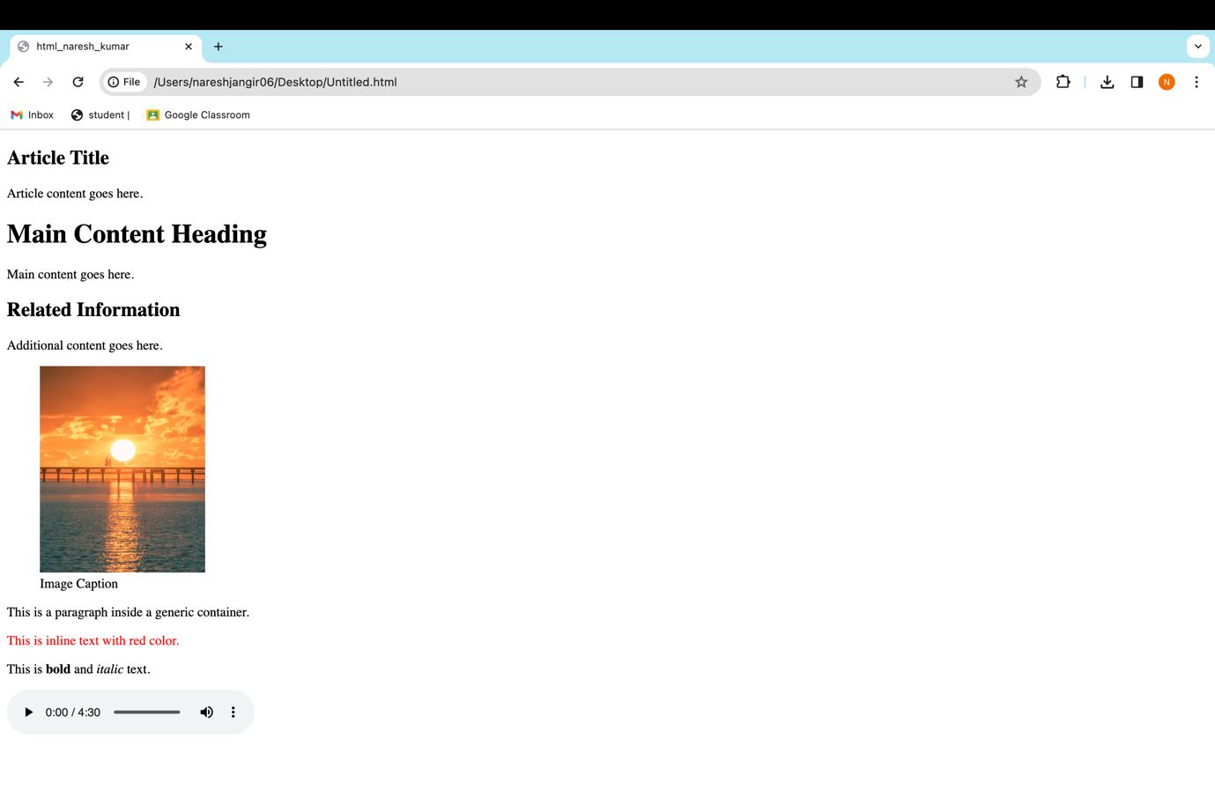

**Example 13 .**

<!DOCTYPE html> <html lang="en">

<head>

<meta charset="UTF-8">

<meta name="viewport" content="width=device-width, initial-scale=1.0"> <title>html_naresh_kumar</title>

</head>

<body>

<article>

<h2>Article Title</h2>

<p>Article content goes here.</p>

</article>

<main>

<h1>Main Content Heading</h1>

<p>Main content goes here.</p>

</main>

<aside>

<h2>Related Information</h2>

<p>Additional content goes here.</p>

</aside>

<figure>

<img src="https://images.unsplash.com/photo-1595064085577-7c2ef98ec311?q=80&w=1000&auto=format&fit=crop&ixlib=rb-4.0.3&ixid=M3wxMjA3fDB8MHxzZWFyY2h8Mnx8ZWFybHklMjBtb3JuaW5nfGVufDB8fDB8fHww" width = 200px alt="Description">

<figcaption>Image Caption</figcaption>

</figure>

<div id="container">

<p>This is a paragraph inside a generic container.</p>

</div>

<span style="color: red;">This is inline text with red color.</span> <p>This is <b>bold</b> and <i>italic</i> text.</p>

<audio controls>

<source src="/Users/nareshjangir06/Downloads/Main-Rang-Sharbaton-Ka(PaglaSongs).mp3" type="audio/mp3"> Your browser does not support the audio tag.

</audio>

<video controls width="480" height="270"> <source src="/Users/nareshjangir06/Downloads/Main Rang Sharbaton Ka Arijit Singh Phata Poster Nikhla Hero 2013_720p.mp4" type="video/mp4"> Your browser does not support the video tag.

</video>

</body>

</html>

**Output**

**Example 14 .**

<!DOCTYPE html> <html lang="en">

<head>

<meta charset="UTF-8">

<meta name="viewport" content="width=device-width, initial-scale=1.0"> <title>html_naresh_kumar</title>

</head>

<body>

<article>

<h2>Article Title</h2>

<p>Article content goes here.</p>

</article>

<main>

<h1>Main Content Heading</h1>

<p>Main content goes here.</p>

</main>

<aside>

<h2>Related Information</h2>

<p>Additional content goes here.</p>

</aside>

<figure>

<img src="https://images.unsplash.com/photo-1595064085577-7c2ef98ec311?q=80&w=1000&auto=format&fit=crop&ixlib=rb-4.0.3&ixid=M3wxMjA3fDB8MHxzZWFyY2h8Mnx8ZWFybHklMjBtb3JuaW5nfGVufDB8fDB8fHww" width = 200px alt="Description">

<figcaption>Image Caption</figcaption>

</figure>

<div id="container">

<p>This is a paragraph inside a generic container.</p>

</div>

<span style="color: red;">This is inline text with red color.</span> <p>This is <b>bold</b> and <i>italic</i> text.</p>

<audio controls>

<source src="/Users/nareshjangir06/Downloads/Main-Rang-Sharbaton-Ka(PaglaSongs).mp3" type="audio/mp3"> Your browser does not support the audio tag.

</audio>

<video controls width="480" height="270"> <source src="/Users/nareshjangir06/Downloads/Main Rang Sharbaton Ka Arijit Singh Phata Poster Nikhla Hero 2013_720p.mp4" type="video/mp4"> Your browser does not support the video tag.

</video>

<video controls width="480" height="270">

<source src="/Users/nareshjangir06/Downloads/Main Rang Sharbaton Ka Arijit Singh Phata Poster Nikhla Hero 2013_720p.mp4" type="video/mp4">

Your browser does not support the video tag.

<track kind="captions" label="English" src="/Users/nareshjangir06/Downloads/[SubtitleTools.com] [English (United Kingdom)] Main Rang Sharbaton Ka - Phata Poster Nikhla Hero I Shahid,Ileana _ Atif Aslam & Chinmayi _ Pritam [DownSub.com].vtt" srclang="en" default>

</video>

</body>

</html>

**Output**

**Example 15 .**

<!DOCTYPE html> <html lang="en">

<head>

<meta charset="UTF-8">

<meta name="viewport" content="width=device-width, initial-scale=1.0"> <title>html_naresh_kumar</title>

</head>

<body>

<article>

<h2>Article Title</h2>

<p>Article content goes here.</p>

</article>

<main>

<h1>Main Content Heading</h1>

<p>Main content goes here.</p>

</main>

<aside>

<h2>Related Information</h2>

<p>Additional content goes here.</p>

</aside>

<figure>

<img src="https://images.unsplash.com/photo-1595064085577-7c2ef98ec311?q=80&w=1000&auto=format&fit=crop&ixlib=rb-4.0.3&ixid=M3wxMjA3fDB8MHxzZWFyY2h8Mnx8ZWFybHklMjBtb3JuaW5nfGVufDB8fDB8fHww" width = 200px alt="Description">

<figcaption>Image Caption</figcaption>

</figure>

<div id="container">

<p>This is a paragraph inside a generic container.</p>

</div>

<span style="color: red;">This is inline text with red color.</span> <p>This is <b>bold</b> and <i>italic</i> text.</p>

<audio controls>

<source src="/Users/nareshjangir06/Downloads/Main-Rang-Sharbaton-Ka(PaglaSongs).mp3" type="audio/mp3"> Your browser does not support the audio tag.

</audio>

<video controls width="480" height="270"> <source src="/Users/nareshjangir06/Downloads/Main Rang Sharbaton Ka Arijit Singh Phata Poster Nikhla Hero 2013_720p.mp4" type="video/mp4"> Your browser does not support the video tag.

</video>

<video controls width="480" height="270">

<source src="/Users/nareshjangir06/Downloads/Main Rang Sharbaton Ka Arijit Singh Phata Poster Nikhla Hero 2013_720p.mp4" type="video/mp4">

Your browser does not support the video tag.

<track kind="captions" label="English" src="/Users/nareshjangir06/Downloads/[SubtitleTools.com] [English (United Kingdom)] Main Rang Sharbaton Ka - Phata Poster Nikhla Hero I Shahid,Ileana _ Atif Aslam & Chinmayi _ Pritam [DownSub.com].vtt" srclang="en" default>

</video>

<canvas id="myCanvas" width="400" height="200"></canvas>

</body>

</html>

**Output**

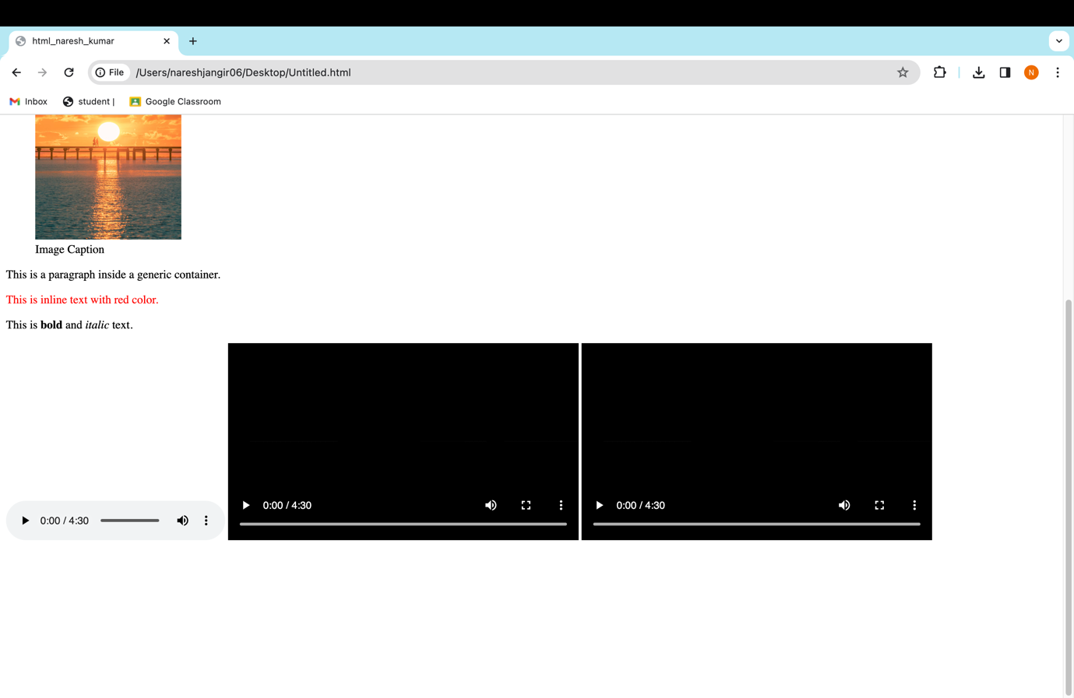

**Example 16 .**

<!DOCTYPE html> <html lang="en">

<head>

<meta charset="UTF-8">

<meta name="viewport" content="width=device-width, initial-scale=1.0"> <title>html_naresh_kumar</title>

</head>

<body>

<article>

<h2>Article Title</h2>

<p>Article content goes here.</p>

</article>

<main>

<h1>Main Content Heading</h1>

<p>Main content goes here.</p>

</main>

<aside>

<h2>Related Information</h2>

<p>Additional content goes here.</p>

</aside>

<figure>

<img src="https://images.unsplash.com/photo-1595064085577-7c2ef98ec311?q=80&w=1000&auto=format&fit=crop&ixlib=rb-4.0.3&ixid=M3wxMjA3fDB8MHxzZWFyY2h8Mnx8ZWFybHklMjBtb3JuaW5nfGVufDB8fDB8fHww" width = 200px alt="Description">

<figcaption>Image Caption</figcaption>

</figure>

<div id="container">

<p>This is a paragraph inside a generic container.</p>

</div>

<span style="color: red;">This is inline text with red color.</span> <p>This is <b>bold</b> and <i>italic</i> text.</p>

<audio controls>

<source src="/Users/nareshjangir06/Downloads/Main-Rang-Sharbaton-Ka(PaglaSongs).mp3" type="audio/mp3"> Your browser does not support the audio tag.

</audio>

<video controls width="480" height="270"> <source src="/Users/nareshjangir06/Downloads/Main Rang Sharbaton Ka Arijit Singh Phata Poster Nikhla Hero 2013_720p.mp4" type="video/mp4"> Your browser does not support the video tag.

</video>

<video controls width="480" height="270">

<source src="/Users/nareshjangir06/Downloads/Main Rang Sharbaton Ka Arijit Singh Phata Poster Nikhla Hero 2013_720p.mp4" type="video/mp4">

Your browser does not support the video tag.

<track kind="captions" label="English" src="/Users/nareshjangir06/Downloads/[SubtitleTools.com] [English (United Kingdom)] Main Rang Sharbaton Ka - Phata Poster Nikhla Hero I Shahid,Ileana _ Atif Aslam & Chinmayi _ Pritam [DownSub.com].vtt" srclang="en" default>

</video>

<canvas id="myCanvas" width="400" height="200"></canvas>

<script>

// Get the canvas element

var canvas = document.getElementById("myCanvas");

// Get the 2D rendering context

var ctx = canvas.getContext("2d");

// Perform drawing operations using the context

ctx.fillStyle = "red";

ctx.fillRect(10, 10, 50, 50);

</script>

</body>

</html>

**Output**

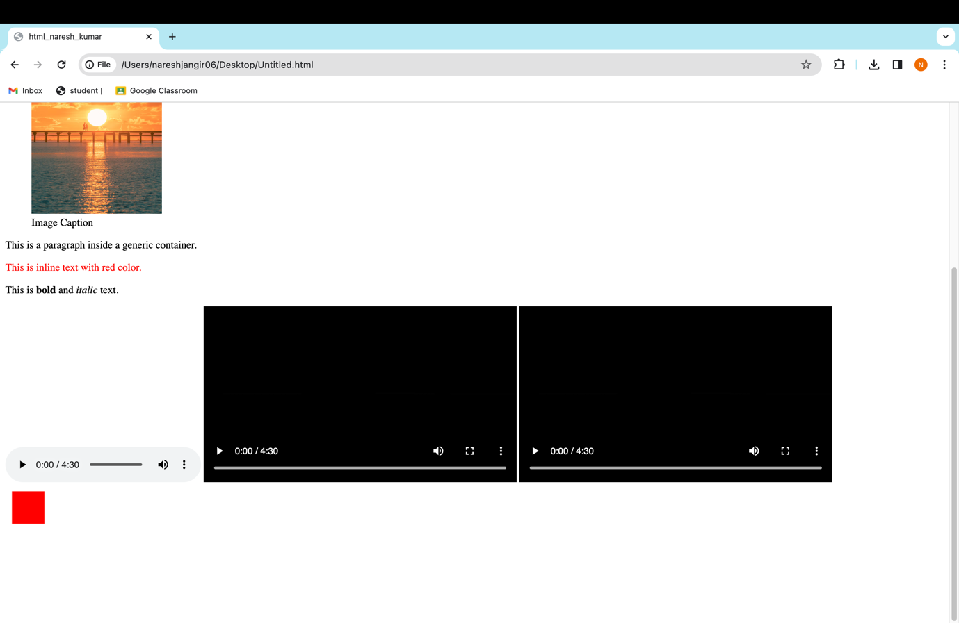

**Example 17 .**

<!DOCTYPE html> <html lang="en">

<head>

<meta charset="UTF-8">

<meta name="viewport" content="width=device-width, initial-scale=1.0"> <title>html_naresh_kumar</title>

</head>

<body>

<article>

<h2>Article Title</h2>

<p>Article content goes here.</p>

</article>

<main>

<h1>Main Content Heading</h1>

<p>Main content goes here.</p>

</main>

<aside>

<h2>Related Information</h2>

<p>Additional content goes here.</p>

</aside>

<figure>

<img src="https://images.unsplash.com/photo-1595064085577-7c2ef98ec311?q=80&w=1000&auto=format&fit=crop&ixlib=rb-4.0.3&ixid=M3wxMjA3fDB8MHxzZWFyY2h8Mnx8ZWFybHklMjBtb3JuaW5nfGVufDB8fDB8fHww" width = 200px alt="Description">

<figcaption>Image Caption</figcaption>

</figure>

<div id="container">

<p>This is a paragraph inside a generic container.</p>

</div>

<span style="color: red;">This is inline text with red color.</span> <p>This is <b>bold</b> and <i>italic</i> text.</p>

<audio controls>

<source src="/Users/nareshjangir06/Downloads/Main-Rang-Sharbaton-Ka(PaglaSongs).mp3" type="audio/mp3"> Your browser does not support the audio tag.

</audio>

<video controls width="480" height="270"> <source src="/Users/nareshjangir06/Downloads/Main Rang Sharbaton Ka Arijit Singh Phata Poster Nikhla Hero 2013_720p.mp4" type="video/mp4"> Your browser does not support the video tag.

</video>

<video controls width="480" height="270">

<source src="/Users/nareshjangir06/Downloads/Main Rang Sharbaton Ka Arijit Singh Phata Poster Nikhla Hero 2013_720p.mp4" type="video/mp4">

Your browser does not support the video tag.

<track kind="captions" label="English" src="/Users/nareshjangir06/Downloads/[SubtitleTools.com] [English (United Kingdom)] Main Rang Sharbaton Ka - Phata Poster Nikhla Hero I Shahid,Ileana _ Atif Aslam & Chinmayi _ Pritam [DownSub.com].vtt" srclang="en" default>

</video>

<canvas id="myCanvas" width="400" height="200"></canvas>

<script>

// Get the canvas element

var canvas = document.getElementById("myCanvas");

// Get the 2D rendering context

var ctx = canvas.getContext("2d");

// Perform drawing operations using the context

ctx.fillStyle = "red";

ctx.fillRect(10, 10, 50, 50);

function draw()

{

var canvas = document.getElementById("myCanvas"); var ctx = canvas.getContext("2d");

// Perform drawing operations

requestAnimationFrame(draw); // Call draw function again for the next animation frame

}

draw(); // Initial call to start the animation loop

</script>

</body>

</html>

**Output**



**Example 18 .**

<!DOCTYPE html> <html lang="en">

<head>

<meta charset="UTF-8">

<meta name="viewport" content="width=device-width, initial-scale=1.0"> <title>html_naresh_kumar</title>

</head>

<body>

<article>

<h2>Article Title</h2>

<p>Article content goes here.</p>

</article>

<main>

<h1>Main Content Heading</h1>

<p>Main content goes here.</p>

</main>

<aside>

<h2>Related Information</h2>

<p>Additional content goes here.</p>

</aside>

<figure>

<img src="https://images.unsplash.com/photo-1595064085577-7c2ef98ec311?q=80&w=1000&auto=format&fit=crop&ixlib=rb-4.0.3&ixid=M3wxMjA3fDB8MHxzZWFyY2h8Mnx8ZWFybHklMjBtb3JuaW5nfGVufDB8fDB8fHww" width = 200px alt="Description">

<figcaption>Image Caption</figcaption>

</figure>

<div id="container">

<p>This is a paragraph inside a generic container.</p>

</div>

<span style="color: red;">This is inline text with red color.</span> <p>This is <b>bold</b> and <i>italic</i> text.</p>

<audio controls>

<source src="/Users/nareshjangir06/Downloads/Main-Rang-Sharbaton-Ka(PaglaSongs).mp3" type="audio/mp3"> Your browser does not support the audio tag.

</audio>

<video controls width="480" height="270"> <source src="/Users/nareshjangir06/Downloads/Main Rang Sharbaton Ka Arijit Singh Phata Poster Nikhla Hero 2013_720p.mp4" type="video/mp4"> Your browser does not support the video tag.

</video>

<video controls width="480" height="270">

<source src="/Users/nareshjangir06/Downloads/Main Rang Sharbaton Ka Arijit Singh Phata Poster Nikhla Hero 2013_720p.mp4" type="video/mp4">

Your browser does not support the video tag.

<track kind="captions" label="English" src="/Users/nareshjangir06/Downloads/[SubtitleTools.com] [English (United Kingdom)] Main Rang Sharbaton Ka - Phata Poster Nikhla Hero I Shahid,Ileana _ Atif Aslam & Chinmayi _ Pritam [DownSub.com].vtt" srclang="en" default>

</video>

<canvas id="myCanvas" width="400" height="200"></canvas>

<script>

// Get the canvas element

var canvas = document.getElementById("myCanvas");

// Get the 2D rendering context

var ctx = canvas.getContext("2d");

// Perform drawing operations using the context

ctx.fillStyle = "red";

ctx.fillRect(10, 10, 50, 50);

function draw()

{

var canvas = document.getElementById("myCanvas"); var ctx = canvas.getContext("2d");

// Perform drawing operations

requestAnimationFrame(draw); // Call draw function again for the next animation frame

}

draw(); // Initial call to start the animation loop

</script>

<svg width="200" height="200"> <!-- SVG content goes here -->

</svg>

</body>

</html>

**Output**

**Example 19 .**

<!DOCTYPE html> <html lang="en">

<head>

<meta charset="UTF-8">

<meta name="viewport" content="width=device-width, initial-scale=1.0"> <title>html_naresh_kumar</title>

</head>

<body>

<article>

<h2>Article Title</h2>

<p>Article content goes here.</p>

</article>

<main>

<h1>Main Content Heading</h1>

<p>Main content goes here.</p>

</main>

<aside>

<h2>Related Information</h2>

<p>Additional content goes here.</p>

</aside>

<figure>

<img src="https://images.unsplash.com/photo-1595064085577-7c2ef98ec311?q=80&w=1000&auto=format&fit=crop&ixlib=rb-4.0.3&ixid=M3wxMjA3fDB8MHxzZWFyY2h8Mnx8ZWFybHklMjBtb3JuaW5nfGVufDB8fDB8fHww" width = 200px alt="Description">

<figcaption>Image Caption</figcaption>

</figure>

<div id="container">

<p>This is a paragraph inside a generic container.</p>

</div>

<span style="color: red;">This is inline text with red color.</span> <p>This is <b>bold</b> and <i>italic</i> text.</p>

<audio controls>

<source src="/Users/nareshjangir06/Downloads/Main-Rang-Sharbaton-Ka(PaglaSongs).mp3" type="audio/mp3"> Your browser does not support the audio tag.

</audio>

<video controls width="480" height="270"> <source src="/Users/nareshjangir06/Downloads/Main Rang Sharbaton Ka Arijit Singh Phata Poster Nikhla Hero 2013_720p.mp4" type="video/mp4"> Your browser does not support the video tag.

</video>

<video controls width="480" height="270">

<source src="/Users/nareshjangir06/Downloads/Main Rang Sharbaton Ka Arijit Singh Phata Poster Nikhla Hero 2013_720p.mp4" type="video/mp4">

Your browser does not support the video tag.

<track kind="captions" label="English" src="/Users/nareshjangir06/Downloads/[SubtitleTools.com] [English (United Kingdom)] Main Rang Sharbaton Ka - Phata Poster Nikhla Hero I Shahid,Ileana _ Atif Aslam & Chinmayi _ Pritam [DownSub.com].vtt" srclang="en" default>

</video>

<canvas id="myCanvas" width="400" height="200"></canvas>

<script>

// Get the canvas element

var canvas = document.getElementById("myCanvas");

// Get the 2D rendering context

var ctx = canvas.getContext("2d");

// Perform drawing operations using the context

ctx.fillStyle = "red";

ctx.fillRect(10, 10, 50, 50);

function draw()

{

var canvas = document.getElementById("myCanvas"); var ctx = canvas.getContext("2d");

// Perform drawing operations

requestAnimationFrame(draw); // Call draw function again for the next animation frame

}

draw(); // Initial call to start the animation loop

</script>

<svg width="200" height="200"> <!-- SVG content goes here -->

</svg>

<svg width="200" height="200">

<rect width="100" height="100" fill="blue" />

<circle cx="50" cy="50" r="40" fill="green" />

<path d="M10 80 Q 95 10 180 80" fill="transparent" stroke="black" />

<text x="20" y="40" font-family="Arial" font-size="20" fill="red">Hello, SVG!</text>

</svg>

</body>

</html>

**Output.**

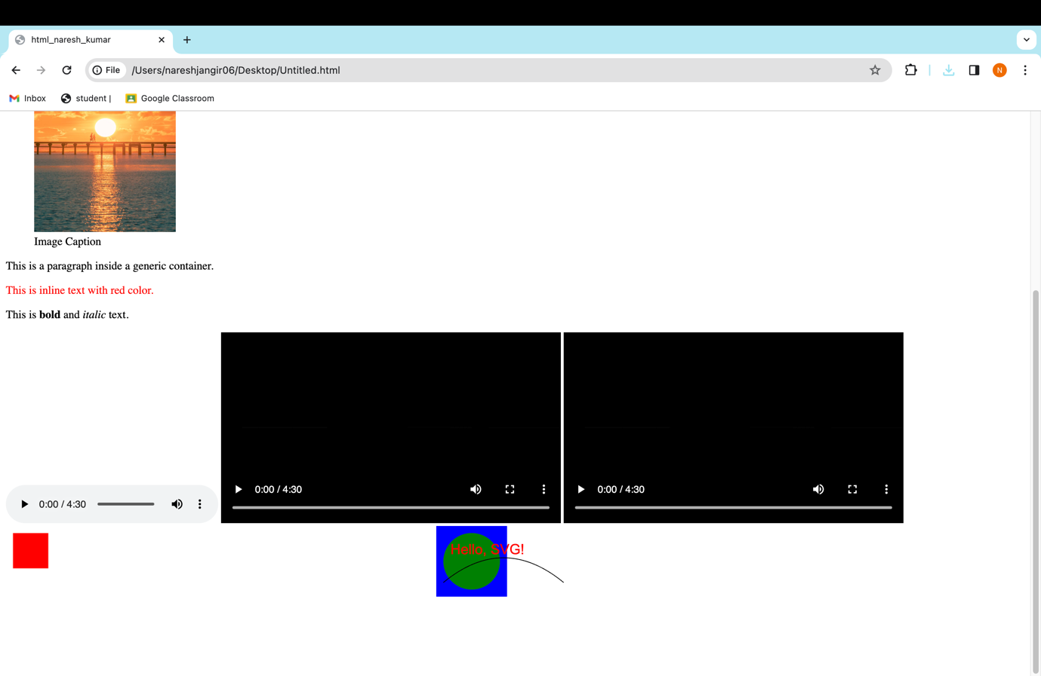

**Example 20 .**

<!DOCTYPE html> <html lang="en"> <head>

<meta charset="UTF-8">  
<meta name="viewport" content="width=device-width, initial-scale=1.0"> <title>SVG Example</title>

</head> <body>

<h1>SVG Example</h1>

<svg width="200" height="200">  
<circle cx="100" cy="100" r="80" fill="orange" />

</svg>

<p>This is a simple SVG circle embedded in an HTML document.</p>

</body> </html>

**Output**

**Example 21 .**

<!DOCTYPE html> <html lang="en"> <head>

<meta charset="UTF-8">

<meta name="viewport" content="width=device-width, initial-scale=1.0"> <title>SVG Example</title>

</head>

<body>

<h1>SVG Example</h1>

<svg width="200" height="200">

<circle cx="100" cy="100" r="80" fill="orange" />

</svg>

<p>This is a simple SVG circle embedded in an HTML document.</p>

<img src="/Users/nareshjangir06/Downloads/genetic-algorithm-svgrepo-com.svg" width = 350 pc alt="Circle SVG">

<object type="image/svg+xml" data="/Users/nareshjangir06/Downloads/genetic-algorithm-svgrepo-com.svg" width="200" height="200">

Your browser does not support SVG.

</object>

</body>

</html>

**Output**

